My Snowman

If you are 9 years old draw brown eyes on your snowman.

If you are 8 years old or younger draw blue eyes on your snowman.

If you have a pet draw a funny face on your snowman.

If you do not have a pet draw a surprised or happy face on your snowman.

Now buttons! If you have 4 siblings, put 4 buttons on your snowman.

If you are a boy put a green flower on your snowman’s hat.

If you are a girl put a purple flower on your snowman’s hat.

Now draw a beautiful snowy scene behind your snowman! You have 5 minutes!!

Snowman Bingo

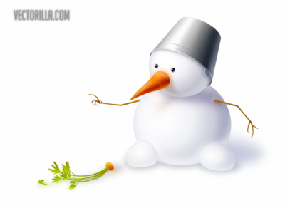

Blue Eyes  Funny Face | 5 or more buttons | A green flower | Tell someone a good joke | A purple flower with 2 buttons
A purple flower and a surprised face | Do 5 push-ups with someone | Blue eyes and 1 button | Brown eyes | More than 3 buttons
Brown eyes and a green flower | A green flower | FREE SPACE! | A funny face that made you laugh | Do 10 jumping jacks with someone
More than 4 buttons | A background with a person or animal | Green flower and a surprised face | A purple flower | Blue eyes
A purple flower | Sign “Hi, How are you” | 2 buttons only | A beautiful snowy background | A surprised face

