Halloween
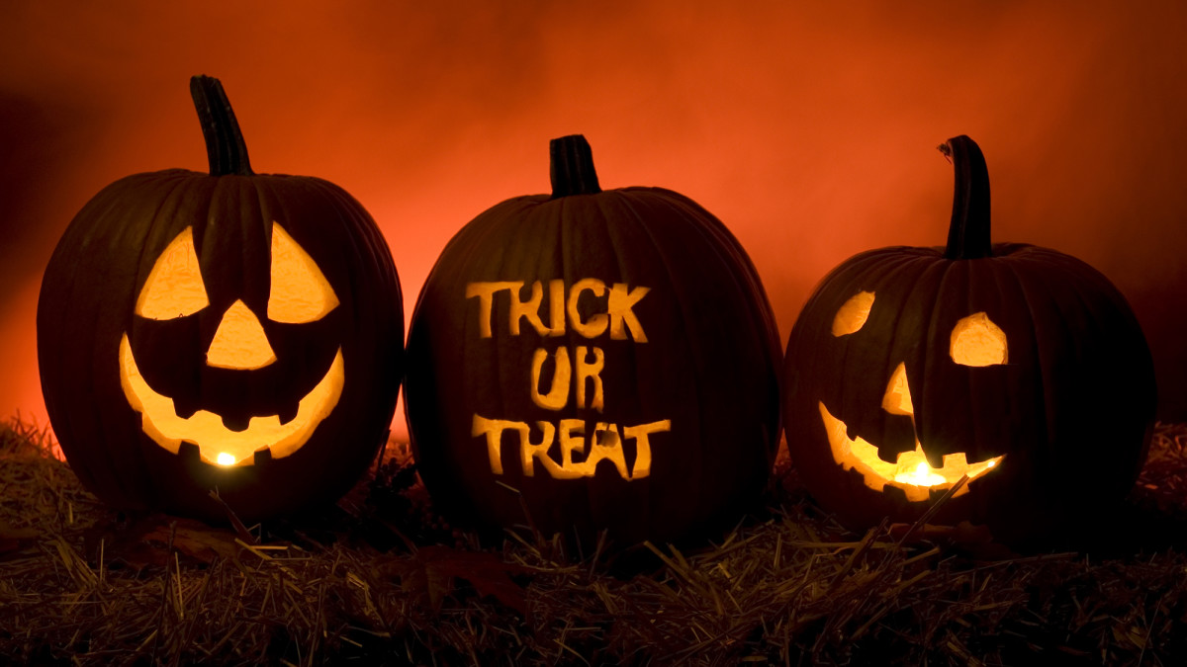

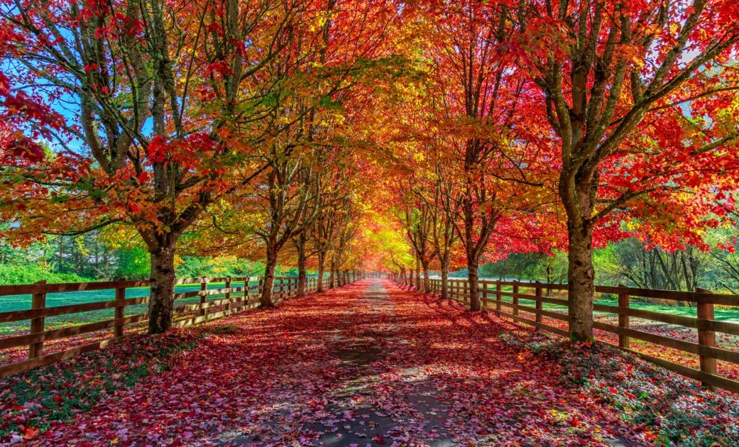

October is the first full month of Fall. The leaves change colors and the weather gets cooler. Some people celebrate Fall by eating pumpkin flavored food, decorating their house for Halloween, and preparing a costume to wear on Halloween.

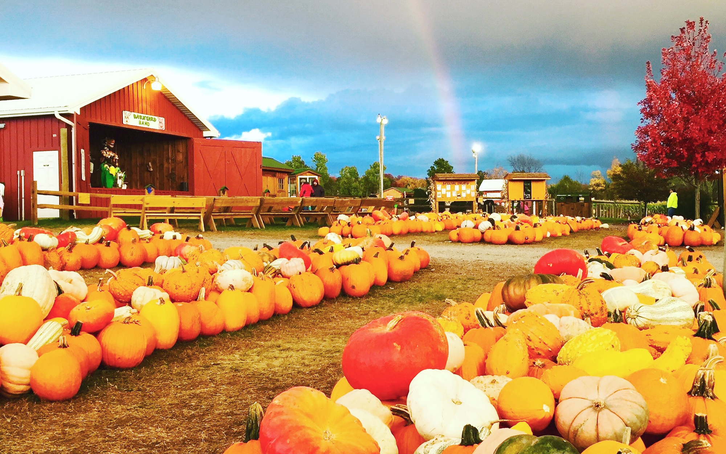

People farm pumpkins and sell them to stores or sell them at pumpkin patches. A pumpkin patch sells pumpkins of all sizes. Sometimes they have rides or activities, like face painting or train rides. Have you ever been to a pumpkin patch?

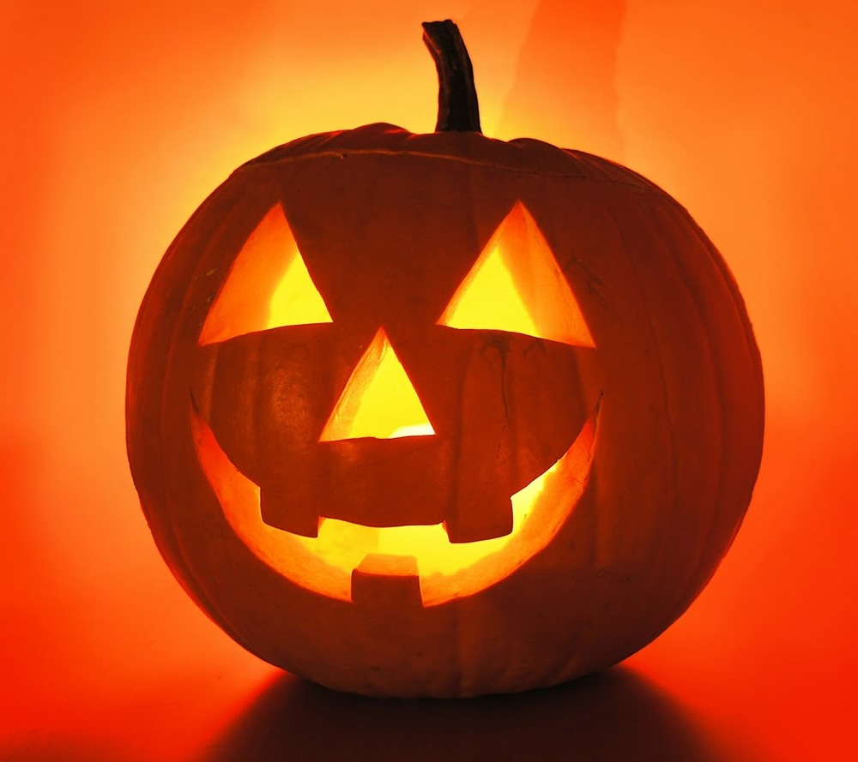

People bring the pumpkins home and use them to decorate their house. Some people carve jack-o-lanterns. When you carve a pumpkin, you first have to ask ad adult to cut off the top of the pumpkin and help you take out the seeds. After taking out the seeds, you can bake them and eat them!

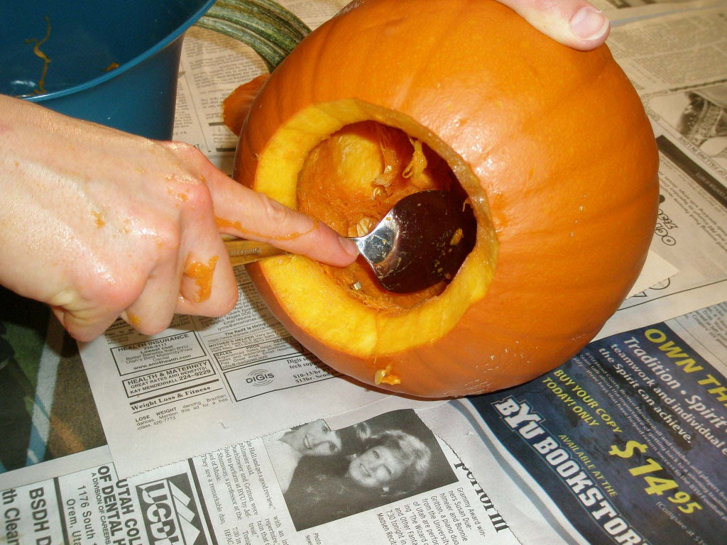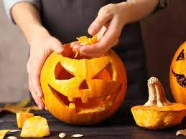

After you clean out the pumpkin, with the help of an adult, you can design a face on the pumpkin to cut out. Once the design is done, you can light a candle to put inside the pumpkin for a cool illusion at night time!

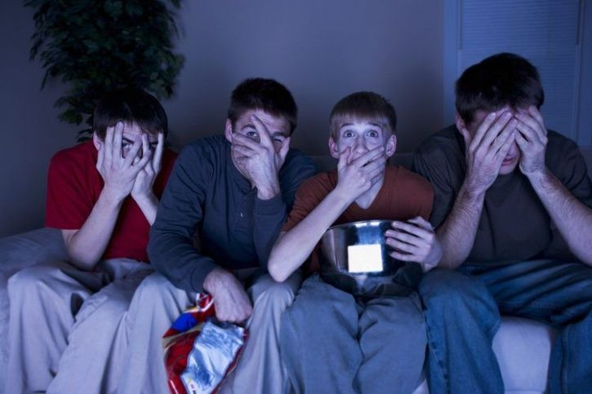

During the month of October, some people like to watch scary movies or tell scary stories. People talk about spiders, ghosts, zombies, and witches! If you ever feel scared, tell an adult you need a break.

On October 31st, children go trick-or-treating! This is the big night when everyone gets dressed in their Halloween costume.

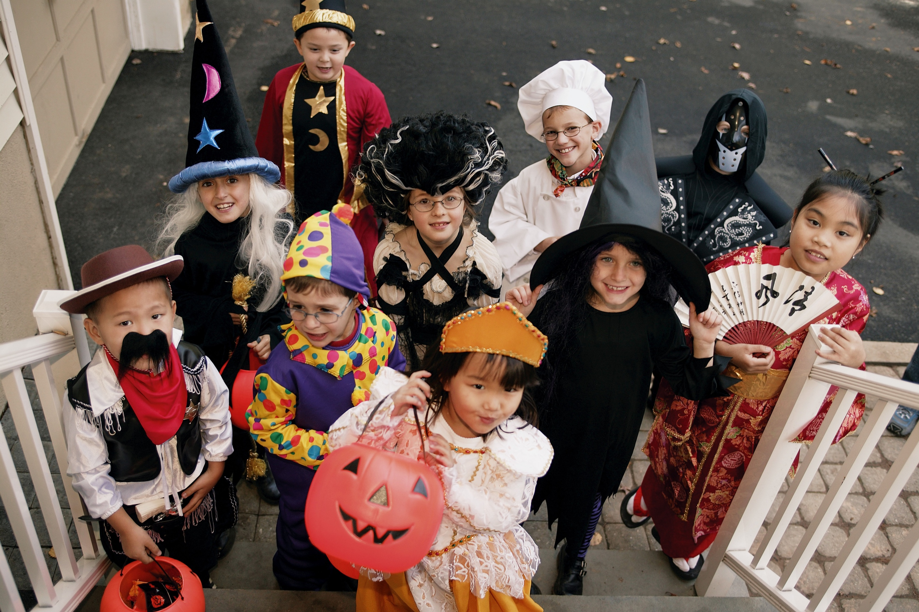

Then with a trusted adult, you go and knock on the door, and when someone answers you say, “trick-or-treat!”
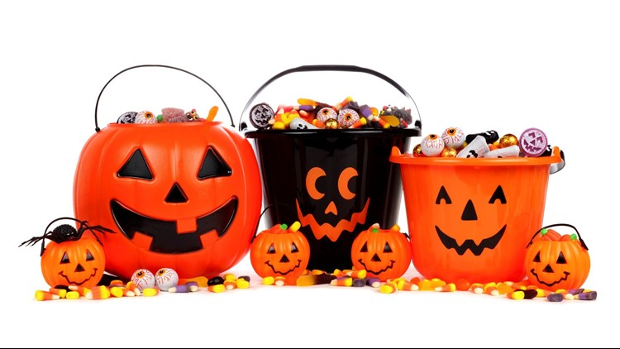

Some people will hand out candy, some people might have a healthy snack, and some people might have their entry ways look scary. After you get your treat, make sure to say, “THANK YOU!”

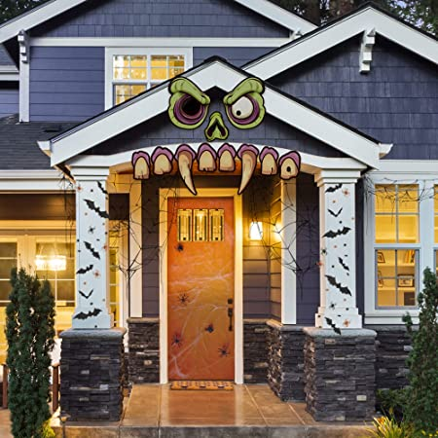

Remember this is all fake. But it can be scary. If you are scared you can tell the adult you are with or hold their hand. They will make sure you feel safe. You can also ask to skip a house if it is too scary. Fall events are here to be fun!

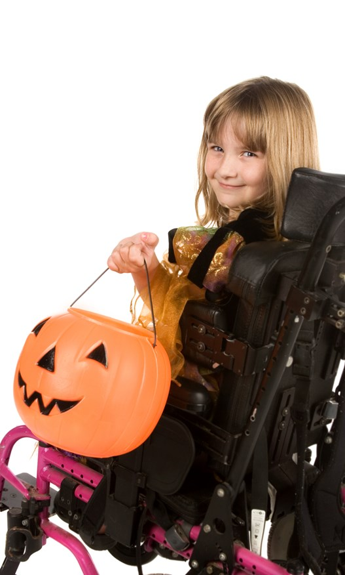

Also remember not to eat too much candy or you can feel sick! But most of all, have a great time!

