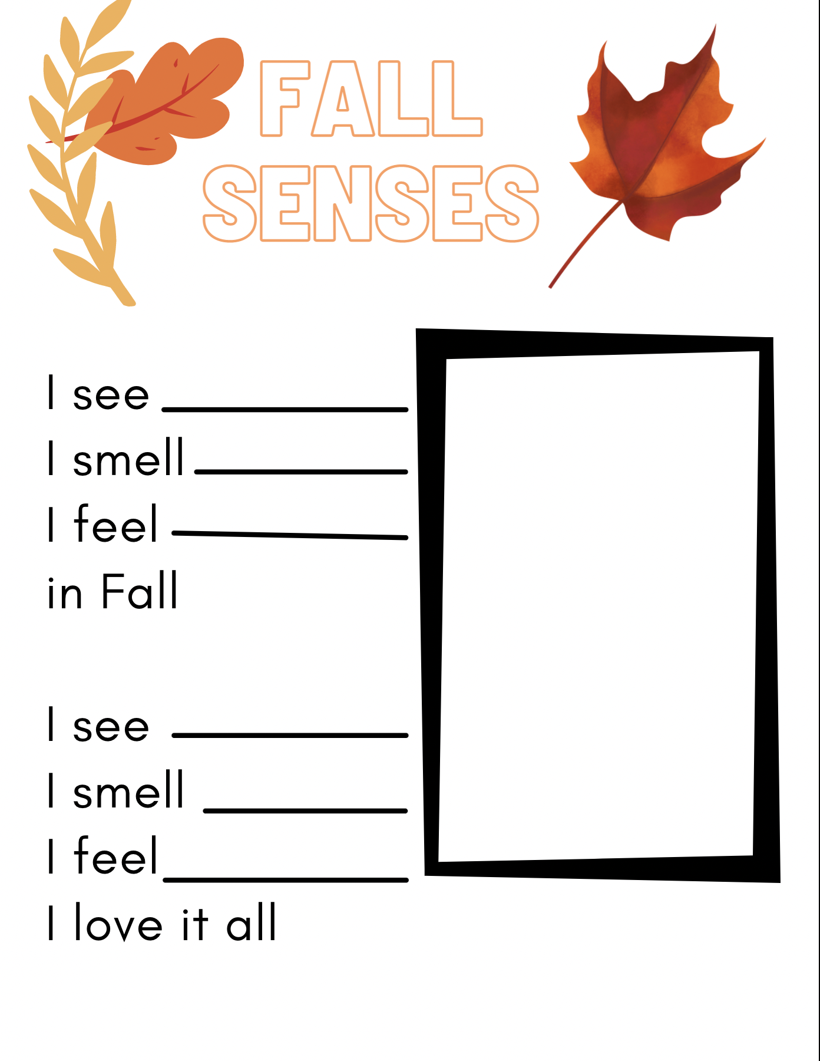

leaves cold air pumpkins

black cat cider fire place

sweaters hot cocoa turkey

orange scarves costumes

